

**Ankara Yıldırım Beyazit University**

**Business School**

**Esenboğa, Ankara**

-------------------------------

**2020-2021**

**------------------------**

**Ecem Sol**

**17030411058**

**Management Information System**

**The Socioeconomic Impact of the COVID-19 Pandemic on Turkish Society**

**Abstract**

Pandemics leave significant marks on the memories of societies with their permanent impacts. Going beyond a cause of disease or death, they can have consequences in many aspects, psychological, social and economic ones being in the first place. The Covid-19 outbreak, which first emerged in China and has spread to the whole world as of the first months of 2020, has the potential to constitute a breaking the course of history, as well. Turkey is located on the transit point between Asia and Europe with its geographical position, and thus, received its share from the outbreak of Covid-19, which spreads through social contact. The first official case was recorded on 11 March 2020, and then the virus spread rapidly.

**Introduction**

With the spread of the virus, people start to socialize less and avoid excessive consumption except for their basic needs during quarantine processes. This significant decrease in consumption has a negative impact on the economy. Employers are following some methods to be less affected by the damages caused by the COVID-19 epidemic. For example; They follow a policy of shrinking their companies, some of them give unpaid leave to their employees, and some of them are in a position to close their workplaces completely. This situation brings along unemployment and unemployment brings poverty with it. Thus, the level of unemployment and poverty in our country is increasing even more.

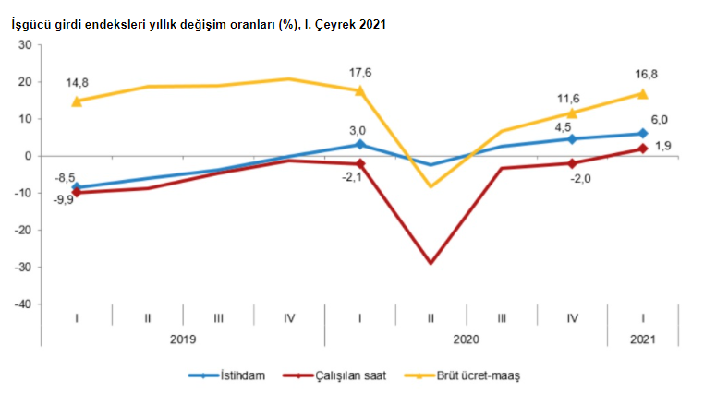

As you can see, in the second quarter of 2020 (TUIK), that is, when Covid-19 first broke out, workers could not go to their workplaces due to the quarantine made to prevent the spread of the virus. As a result, the workforce experienced a significant decrease. Many factories, private organizations, and government agencies ceased their operations.

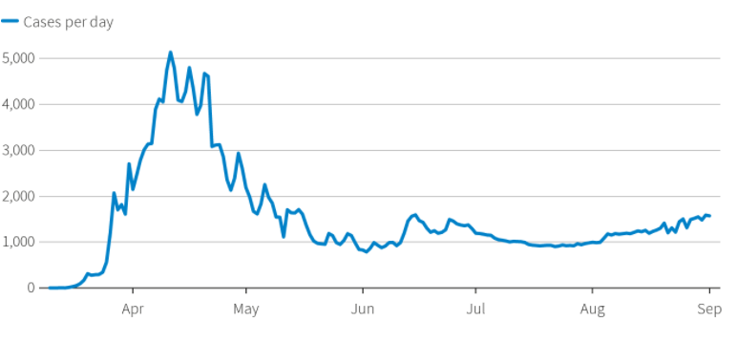

*Rate of coronavirus cases until in September,2020.*

Since there was an unknown virus in the world, it was not known what to do and acted out of control. The people, who started to consume excessively with the fear of sudden cut salaries and shortage of food, began to impoverish at the same rate. Firms that could not keep up with the process laid off most of their workers, resulting in massive unemployment.

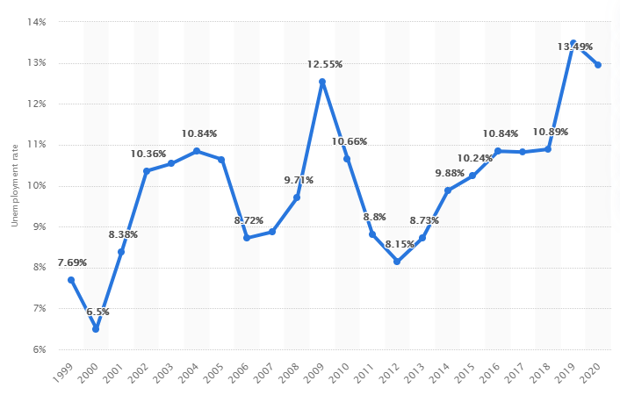

*In 2020, the unemployment rate in Turkey was at about 12.94 percent.*

Like the rest of the world, the Turkish people, who had a psychological collapse, had a hard time adapting to the current situation. Pieces of education began to continue online, and in this process, most companies switched to home office logic. Those who were unable to do their jobs online lost their jobs because their employers suffered a great loss. If we consider the general average of Turkey, we can say that many families have an average income. If we assume families that are below the average and have a very close average income, we are on the verge of a great psychological depression.

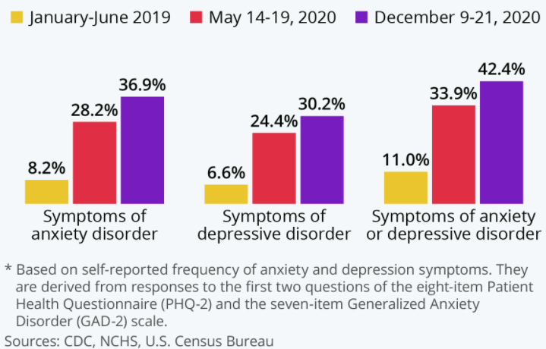

Even though the table above covers the whole world, I think that the situation of people under middle income in Turkey – and even Turkish people in general – is like this. The fact that we were in a constantly fluctuating economic situation did not make the people feel comfortable before Covid-19. However, I can say that with the Coranavirus, anxiety and depression, and even social distance, the feeling of being stuck increases considerably compared to the people around me.

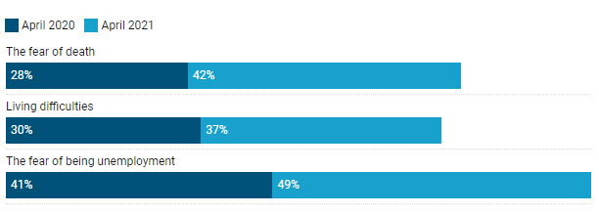

According to a report released on Friday, the COVID-19 epidemic and subsequent lockdowns caused psychological problems in Turkey, including sadness and dread of death. Turkey's Istanbul University performed a study to map the psychological cost of the epidemic in the country, finding that the pandemic considerably contributed to the decline in "life satisfaction" among Turkish citizens.

A study team led by Veysel Bozkurt interviewed approximately 10,000 educated, middle-class adults aged 18 to 77.The research was conducted in April 2020, when the impacts of the epidemic began to be noticed in Turkey, and then again in April 2021, one year later.

According to the poll, fear of death climbed to 42% in 2021 from 28% in 2020, and fear of becoming infected with the virus grew to 48% in 2021 from 41% in 2020. In comparison to a year ago, the study found that more individuals were suffering from depressive symptoms. While 31% of respondents felt a loss of control over their lives in April 2020, this number jumped to 44% in April 2021.

Over 51% of poll respondents said they had trouble sleeping, and 41% said they had trouble handling their daily responsibilities. Furthermore, as of April 2021, 65 percent of the individuals felt tiredness symptoms, while 51 percent claimed their feelings of loneliness had grown.

Intra-family interactions and communication have also deteriorated significantly, according to survey participants, particularly women. On the plus side, the Turkish family system proved to be a refuge in difficult times, with 65 percent of respondents stating that family members financially helped one other.

In an interview with Anadolu Agency, Bozkurt said that, despite intra-family financial assistance, increasing economic situations had a detrimental impact on people's mental health and family relationships.

**Results:**

Despite the fact that pandemics have severe psychological consequences such as melancholy, anxiety, dread of death, phobias, and psychotic symptoms, people's reactions to such stressful events varied considerably between cultures and even within the same society. Similarly, the COVID-19 pandemic is impacting a substantial portion of the global population, either directly or indirectly. Problems caused by COVID-19 usually lead to fear, anxiety, and phobias in somatic, social, economic, and psychological dimensions, which are already being reported by researchers in China. Similarly, studies conducted in different parts of the world also show that individuals experience similar psychological problems due to COVID-19. This study was an attempt to show the effects of COVID-19 in the Turkish population.

According to this result, many people have experienced and even are living with economic-based psychological problems during the pandemic.

**Presentation link:**

<https://drive.google.com/file/d/1NrGSvg4c5ij-A4KXjbMbQxC6POEqT9eo/view?usp=sharing>